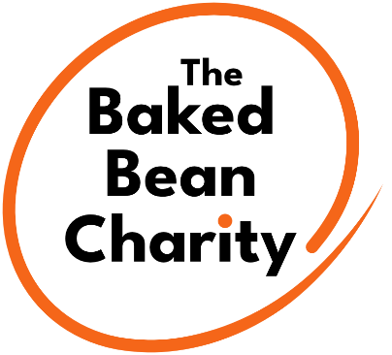
Baked Bean Charity Application Form

Name:
Preferred Name:
Date of Birth:
Referral Date:

- Personal Details
Address:
Post Code:
Living Situation:

Telephone No: Home: Mobile:
Email:

Name of ‘Point of Contact’ at home:
Relationship to you:
Telephone No: Home: Mobile:
Email:

- Social Worker Details
Name:
Borough:
Telephone No: Office: Mobile:
Email:

- Do you have any medical/health conditions or disabilities we should know about before your visit?

- Do you display any behaviours that challenge? Please note any triggers for behaviours and how to best support you.

- Is there anything else you would like to tell us before your visit?

- What days are you currently free to attend a Baked Bean Charity project? Choose as many days as you like. The more the better!

Monday

Tuesday

Wednesday

Thursday

Friday

Saturday Please note this is for Youth Theatre only

- What type of Baked Bean Charity project are you interested in? Choose as many as you like. We like to think we’ve got something for everyone!

Drama Filmmaking

Dance Arts & Crafts

Singing Health & Wellbeing

Music/DJ’s Fitness

- How did you hear about us?

School/college Social media
e.g. Facebook/Instagram

Social worker Google search

Networking event Website
/conference

Word of Mouth Other
e.g. friends/family

Once completed please return the document to:
The Baked Bean Charity
Wilditch Community Centre
48 Culvert Road
London
SW11 5BB

or via email at

join@bakedbeancharity.uk

If you have any further questions or require any further information, please don’t hesitate to contact the office on 020 8944 0024.

We look forward to receiving your application form!

